* When user clicks on the icon of app, the android operating system sends notification to the app and it runs the oncreate method. If another app is opened our app will go on the background. In cases where current app need resources, our app in background will be killed by operating system. But before operating system does anything they will send notifications as well. That’s how a lifecycle of android ends. 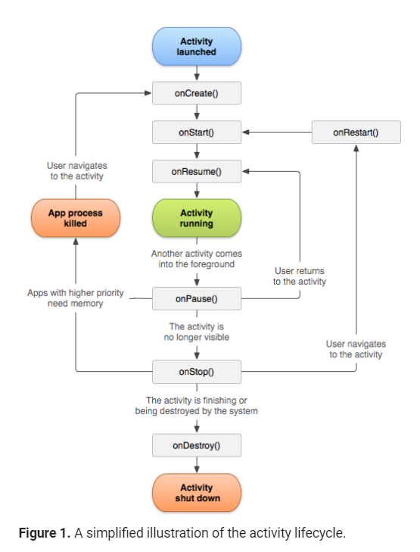
* First **Oncreate(Bundle SavendInstanceState)** method is called. Then **onStart()** method is called.
* Then **onResume()** method is called. It lets the app know that the application is in the foreground and users can interact with it. In other words, the application is in the running state
* When the application goes into background, **onPause()** method is called.
* In case we come from **onPause()** state to foreground again, **onStart() -> onResume()** method are called. *In this case the Oncreate() method will not be called.*
* In case we press home button and make the application not visible at all, then **onStop()** method is called. This is the time when we should stop the UI updates, like if playing a video or something cause its waste of resource. Once we bring the app in foreground again, **onStart() -> onResume()** method are called. Again, onCreate() method will not be called. This is the state where we should save our essential data, cause the operating system can shut it down in case it need resource.
* The final method in the app lifecycle is **onDestroy().** It is called once application is dead. In this state we would want to shut down any server connection, any thread running etc. 
* We can use **onSaveInstanceState()** method to save things inside the bundle. We can store them as key,value pair like a map. When the onCreate() method starts the savedInstanceState is null if we don’t put anything there. In case we put something there , we can use logic to get the data. 